6A^{th} Grade: Unit 7, Lesson 2

- What is the height of the triangle shown?
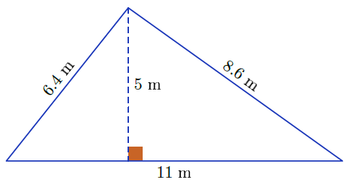
5 units

- What is the value of the expression $\frac{1}{2}(5)(8)$?

20

- What is the base of the triangle shown?
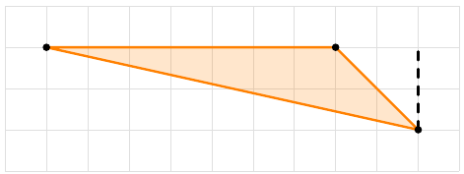
7 units

